**WEEK 9**

**AIM:** Write a program to demonstrate sessions and cookies in Django.

**DESCRIPTION:**

**Django Sessions:** A session is a mechanism to store information on the server side during the interaction with the web application.

In Django, by default session stores in the database and also allows file-based and cache based sessions. It is implemented via a piece of middleware and can be enabled by using the following code.

**Django Cookie:**A cookie is a small piece of information which is stored in the client browser. It is used to store user's data in a file permanently (or for the specified time).

Cookie has its expiry date and time and removes automatically when gets expire. Django provides built-in methods to set and fetch cookie.

The **set_cookie()** method is used to set a cookie and **get()** method is used to get the cookie.

The **request.COOKIES['key']** array can also be used to get cookie values.

**PROGRAM(s):**

**Views.py (for Sessions)**

from django.shortcuts import render

from django.http import HttpResponse

def setsession(request):

request.session['name'] = 'Surya'

request.session['email'] = 'surya.thesun@gmail.com'

return HttpResponse("session is set")

def getsession(request):

sname = request.session['name']

semail = request.session['email']

return HttpResponse(sname+" "+semail);

def setcookie(request):

response = HttpResponse("Cookie is set")

response.set_cookie('cookie_key', 'Hello I am cookie')

return response

def getcookie(request):

tutorial = request.COOKIES['cookie_key']

return HttpResponse("Saved Cookie details: "+ tutorial);

**Views.py**

from django.shortcuts import render

from django.http import HttpResponse

# Create your views here.

def count_requests(request):

    if 'count' in request.COOKIES:

        newcount=int(request.COOKIES['count'])+1

    else:

        newcount=1

    response=render(request,'CookiesApp/count.html',{'count':newcount})

    response.set_cookie('count',newcount)

    return response

**urls.py**

from django.contrib import admin

from django.urls import path

from sessiondemo import views

from CookiesApp import views as v3

urlpatterns = [

path('admin/', admin.site.urls),path('formdata/',v1.studentData),

path('studentform',v2.feedbackdata),path('count',v3.count_requests),

path('setsession/', views.setsession),

path('getsession/', views.getsession),

path('setcookie/', views.setcookie),

path('getcookie/', views.getcookie),

]

**count.html**

<!DOCTYPE html>

<body>

    <h1>Page count : {{count}}</h1>

</body>

**OUTPUT:**

Sessions:

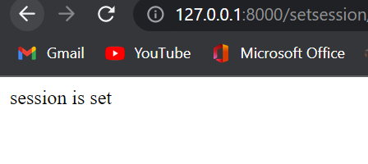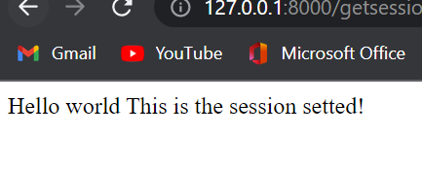

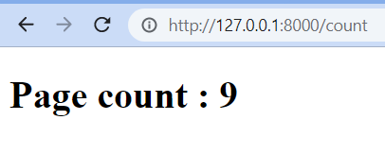

**CONCLUSION:**

The sessions operation on the site is done and we successfully stored the information in set_session page and used it to get it on the get_session page. Also the no.of times a user visits a webpage is counted by cookies methods and displayed it on the same webpage using templates in Django.